## **Laura K. Inamedinova Steps into New Role as** [**Gate.io**](https://www.gate.io//?ch=GM_cgeo500_20241217&utm_campaign=TR_S4kt3obT&utm_content=&utm_medium=PR&utm_source=CH_VZrBR063&utm_term=) **CGEO, Driving Web3 and TradFi Collaboration at Dubai Summits**

**Panama City, Panama --** From December 11 to 13, 2024, Laura K. Inamedinova, newly appointed Chief Ecosystem Officer at [Gate.io](https://www.gate.io//?ch=GM_cgeo500_20241217&utm_campaign=TR_S4kt3obT&utm_content=&utm_medium=PR&utm_source=CH_VZrBR063&utm_term=), marked a strong start to her role by participating in two prominent Dubai events: the Global Blockchain Show and the Global Family Office Investment Summit. Her leadership at these summits showcased her vision for fostering collaboration between traditional finance and blockchain innovation.

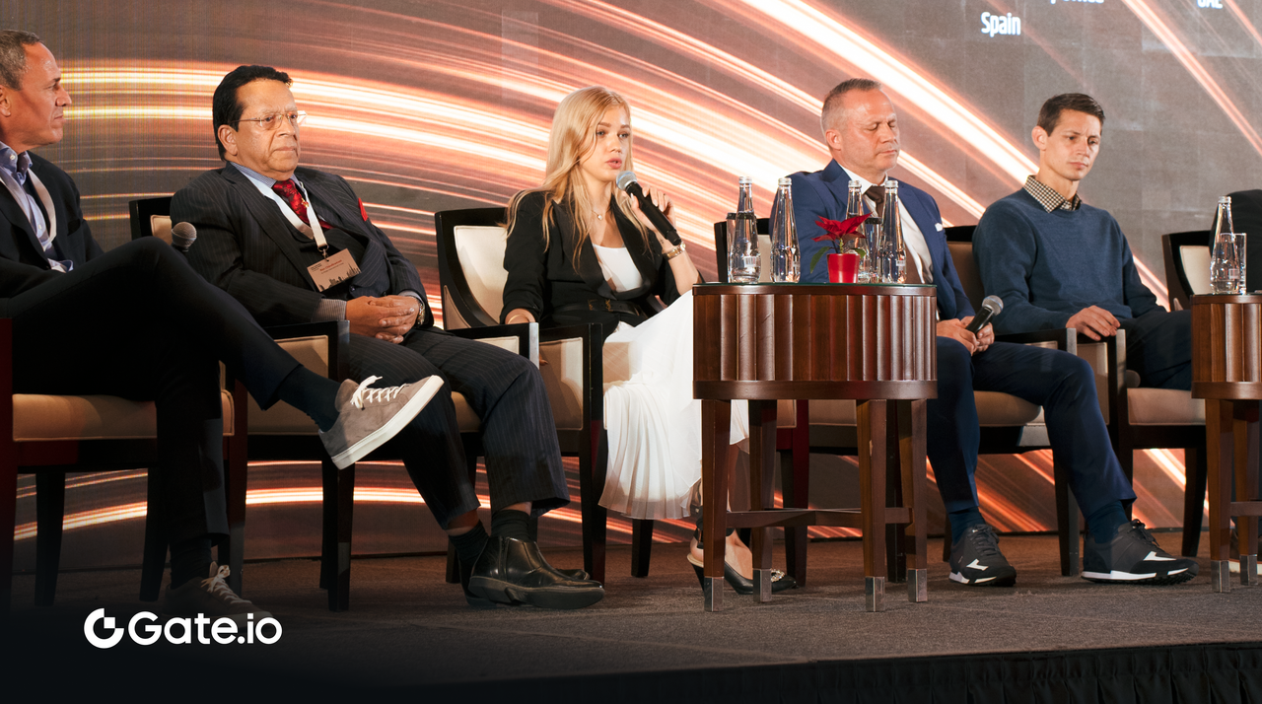

**Shaping the Future of DeFi Derivatives**

At the Global Blockchain Show, Laura led the panel "DeFi Derivatives: Trends, Innovations, and the Road Ahead." The discussion addressed why decentralized finance hasn't matched centralized derivatives markets in scale and what synthetic asset protocols need to evolve. Panelists explored key industry shifts, including the rise of AI-powered trading systems, the implications of MiCA regulations in 2025, and how ETH staking ETFs could impact derivatives markets.

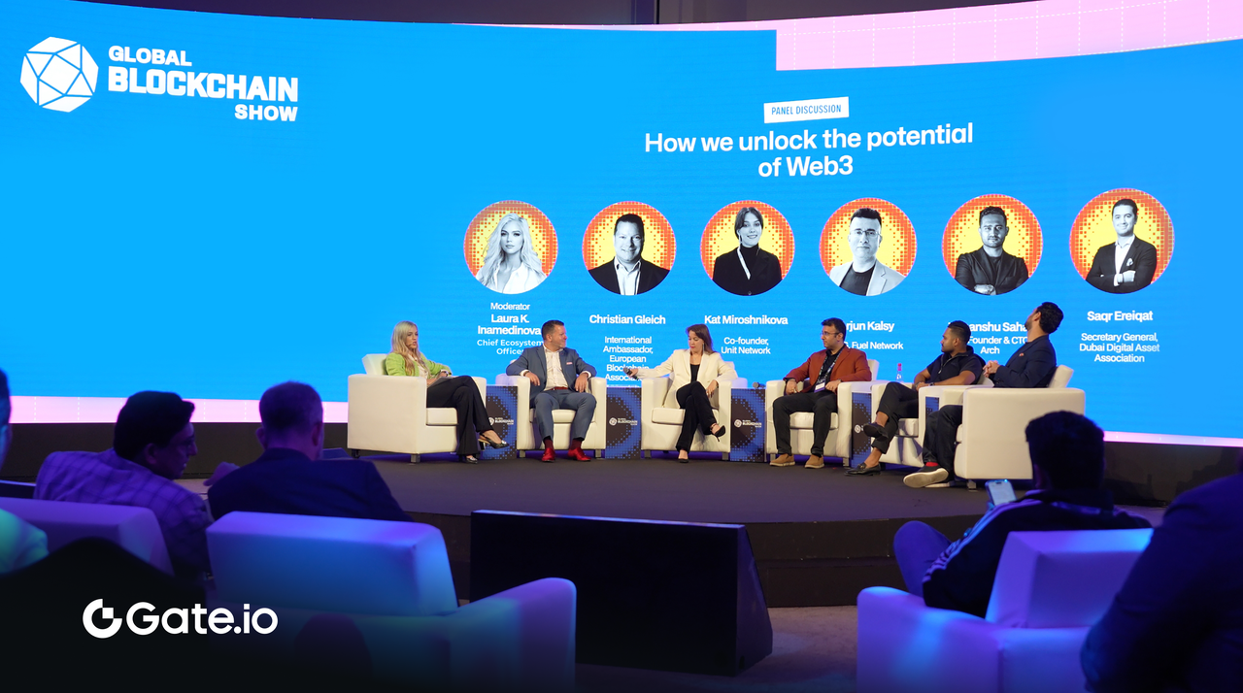

In another panel, "How We Unlock the Potential of Web3," Laura steered dialogue on overcoming barriers to mass adoption. Topics ranged from re-engaging passive crypto users to designing blockchain apps with Web2-style simplicity. Insights included lessons from TON's success in integrating Telegram's user base and practical advice for enterprises adopting stablecoins.

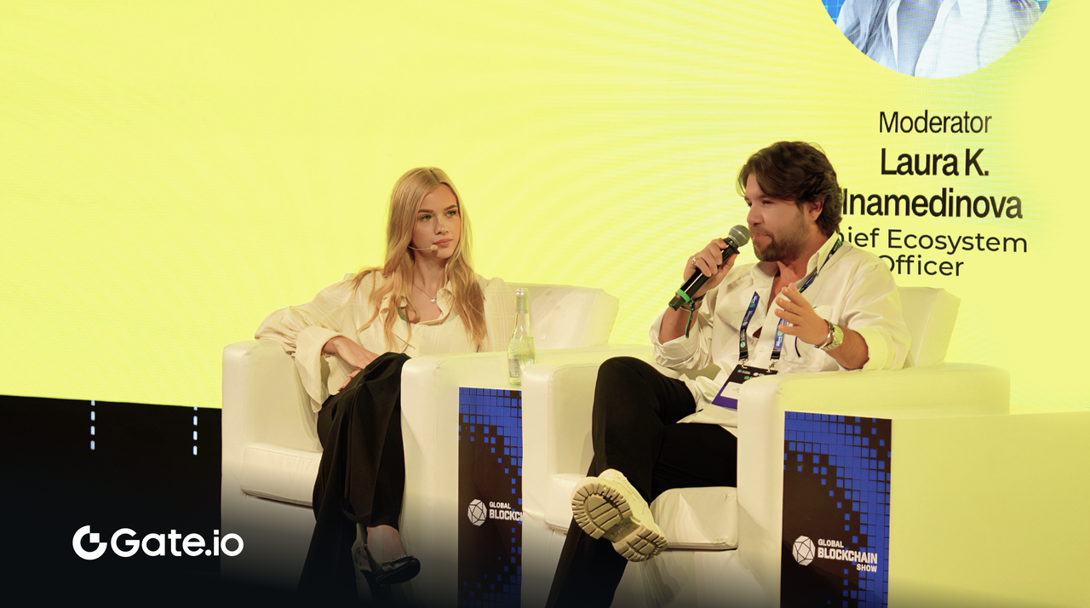

**Connecting Traditional and Decentralized Finance**

At the Global Family Office Investment Summit, Laura hosted a diverse roundtable with global investors and family offices. The discussion centred on identifying synergies between traditional investment strategies and decentralized technologies, providing a platform for sharing actionable insights.

This engagement underscored [Gate.io](https://www.gate.io//?ch=GM_cgeo500_20241217&utm_campaign=TR_S4kt3obT&utm_content=&utm_medium=PR&utm_source=CH_VZrBR063&utm_term=)'s mission to build bridges between traditional financial systems and the decentralized future, driving understanding and collaboration across industries.

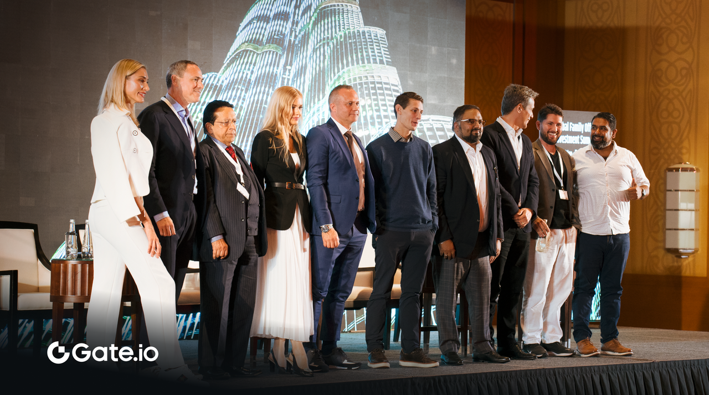

**A Commitment to Progress**

Laura's participation in these events marks an exciting start as Gate.io's new CGEO. Her focus on education, dialogue, and broader ecosystem development aligns with Gate.io's commitment to driving progress in the blockchain space.

Gate.io looks forward to building on this momentum, working alongside the global blockchain community to support innovation and adoption of Web3 technologies.

Media Contact:

Elaine Wang at elaine.w@gate.io

**Disclaimer**:

The content herein does not constitute any offer, solicitation, or recommendation. Please note that virtual assets may depreciate in value fully or partially, and are susceptible to significant fluctuations. You should always seek independent professional advice before making any investment decisions. Please note [Gate.io](http://gate.io/) is not licensed or regulated by the Virtual Asset Regulatory Authority (VARA) and hence not permitted to conduct virtual asset related activities in/from Dubai. The products and/or services mentioned herein are only available to persons outside Dubai. Please be noted that [Gate.io](http://gate.io/) may restrict or prohibit the use of all or a portion of the Services from Restricted Locations. For more information, please read the User Agreement via<https://www.gate.io/zh/user-agreement>.